# Castillo de San Marcos National Monument Answer Key- Fourth Grade Live Distance Learning Program

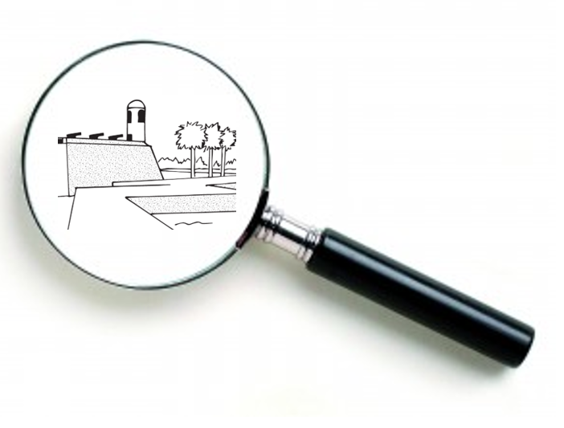Think like an Archeologist!

*As an Archaeologist, you must have practical skills! Observe, explore, investigate, examine! Record your findings!*POSSIBLE ANSWERS:

Tall walls, stone walls, coquina walls, grassy hill, watch towers, moat/ditch, water, fort wall, sea wall, moat wall, covered way wall, etc.

*Archeologists must represent their knowledge and findings. Draw a picture or diagram here of something you observed!*

**\**

POSSIBLE ANSWER: Perhaps the student tries to capture the whole fort, a fort’s feature, or a section of what they are seeing.

*Part of an Archeologist’s job involves studying and analyzing. What can you infer, theorize, suggest based on your observations?*

POSSIBLE ANSWERS: The people who built this fort were afraid of something/needed protection from someone, that’s why they built tall fort walls and surrounded it with more walls.

*Part of an Archeologist’s job involves developing more questions. What questions do you want answered?*

POSSIBLE ANSWER: Who built the fort? When? Why? How?

WORD BANK: *Castillo de San Marcos, St. Augustine, Timucua, artifact, secondary source, Fort Mose, primary source*  
Can you match the words above with their definitions?

|  |  |
| --- | --- |
| 1. Artifact | An object made by a human being (examples: structures, tools, pottery, weapons, jewelry, metal objects). |
| 1. Primary source | An original object, artifact, or first-hand account from people who had a direct connection with it (examples: artifact, diary, photograph, autobiography, video, newspaper). |
| 1. Secondary source | Gives information about a primary source (examples: textbook, biography, documentary, article, or website written about the topic). |
| 1. Timucua | Native American people who lived in Florida for over 12,000 years before the arrival of the Europeans. Many died of diseases brought by the Europeans, some fought back or ran away, some married Spanish soldiers, and some helped built the fort. |
| 1. Castillo de San Marcos | The oldest stone fort in the continental U.S. It was built from coquina, shaped like a star, built by many diverse people (Native Americans, Spanish, Africans, etc.), and owned/used by many nations (Spain, Britain, U.S.). |
| 1. Fort Mose | The first free African American settlement in what is now the U.S. |
| 1. St. Augustine | The oldest permanently occupied European settlement in the U.S. |

*There were many causes and effects of Spanish rule in Florida. Try to identify the 1-8 as a* ***cause*** *(reason) or an* ***effect*** *(result). You can draw lines to the words or write them in each box.*

|  |  |  |
| --- | --- | --- |
| 1. The Spanish wanted to spread Christianity. | **CAUSE?   OR   EFFECT?** | 5. Spain wanted an empire, a lot of areas under their control. |
| 2. Spain wanted to protect their treasure route. | 6. Europeans wanted land, trade, new resources, and new opportunities. |
| 3. Many Native Americans died from diseases spread by the Europeans. | 7. The Spanish built Castillo de San Marcos to protect St. Augustine and their treasure route. |
| 4. St. Augustine became a very diverse society made up of people from different nations, races, languages, and cultures. | 8. The Spanish built many towns, Catholic missions, and forts, like Fort Mose, in Florida. |

Enrichment activity for discussion or writing exercise: **Choose one** of the following questions to answer. Be sure to justify (explain) your answer. POSSIBLE ANSWERS:

* 1. What does the fort represent/symbolize?
     + Protection or safety, because it protected the people of St. Augustine from attack.
     + Survival, building a fort was how the people and their town survived attacks.
     + Diversity, because it was built by Europeans, Africans, and Native Americans.
     + Resourcefulness, because it was built by a local shell stone rock, coquina, and shaped like a star.
     + Conquest, because the Spanish took over Florida and fought with Native Americans and other Europeans.
     + Early America, the fort and St. Augustine are a part of America’s early history.
  2. What can we learn from the fort and the people who came before us?
     + The people of St. Augustine were resilient (strong). They faced many hardships, but did not give up. They kept exploring, building, and working hard.
     + Despite being different from one another, the Spanish, Africans, and Native Americans were still able to build a stone fort that’s over 345 years old and a town that’s over 450 years old.
     + We can learn from the decisions they made, so that we can make good decisions and not repeat their mistakes.
  3. How important are primary sources, like Castillo de San Marcos, when it comes to learning about the past?
     + We need primary sources, because they are more reliable (credible) then secondary sources.
     + Forts and other artifacts give us an opportunity to examine the evidence from the past.
     + Primary sources are exciting! Would you rather explore an old fort or hear your neighbor tell you about one?
  4. Why do you think the fort should be preserved?
     + The fort is the oldest stone fort in the continental United States.
     + The fort is shaped like a star and built from coquina!
     + The fort was built by Europeans, Africans, and Native Americans.
     + The fort saved the people when the enemy attacked!
  5. As a citizen, what are your duties or responsibilities at the Castillo or in other national parks?
     + Visit! Enjoy your visit, but don’t damage parks with pollution or vandalism.
     + Volunteer at a park to help clean it up or teach others about why it’s special.
     + Share parks with other people! Tell others about parks, take them there, or become a ranger or teacher and teach about the parks!

# Castillo de San Marcos National Monument Answer Key- Fourth Grade Live Distance Learning Program for screen reader accessibility.

Think like an Archeologist!

1. *As an Archaeologist, you must listen and learn from others. As the ranger describes Castillo de San Marcos, record the words that stand out to you.* POSSIBLE ANSWERS: After hearing the ranger describe the fort and its outer defenses, they may write tall walls, stone walls, coquina walls, grassy hill, watch towers, moat/ditch, water, fort wall, sea wall, moat wall, covered way wall, etc.
2. *Archeologists must represent their knowledge and findings. The fort’s shape is important. Is Castillo shaped like a square, triangle, star, or circle? Draw that shape that best represents Castillo de San Marcos.*

ANSWER: After hearing the ranger describe the fort, they should draw a star.

1. *Part of an Archeologist’s job involves studying and analyzing. What can you infer, theorize, suggest about* *the people who built this fort?*

POSSIBLE ANSWER: The people who built this fort were afraid of something/needed protection from someone, that’s why they built tall fort walls and surrounded it with more walls.

1. *Part of an Archeologist’s job involves developing more questions. What questions do you want answered?*

POSSIBLE ANSWERS: Who built the fort? When? Why? How?

WORD BANK: *Castillo de San Marcos, St. Augustine, Timucua, artifact, secondary source, Fort Mose, primary source*  
Can you match the words above with their definitions?

|  |  |
| --- | --- |
| 1. Artifact | An object made by a human being (examples: structures, tools, pottery, weapons, jewelry, metal objects). |
| 1. Primary source | An original object, artifact, or first-hand account from people who had a direct connection with it (examples: artifact, diary, photograph, autobiography, video, newspaper). |
| 1. Secondary source | Gives information about a primary source (examples: textbook, biography, documentary, article, or website written about the topic). |
| 1. Timucua | Native American people who lived in Florida for over 12,000 years before the arrival of the Europeans. Many died of diseases brought by the Europeans, some fought back or ran away, some married Spanish soldiers, and some helped built the fort. |
| 1. Castillo de San Marcos | The oldest stone fort in the continental U.S. It was built from coquina, shaped like a star, built by many diverse people (Native Americans, Spanish, Africans, etc.), and owned/used by many nations (Spain, Britain, U.S.). |
| 1. Fort Mose | The first free African American settlement in what is now the U.S. |
| 1. St. Augustine | The oldest permanently occupied European settlement in the U.S. |

|  |  |
| --- | --- |
| *There were many causes and effects of Spanish rule in Florida.* | *Try to identify the 1-8 as a* ***cause*** *(reason) or an* ***effect*** *(result).* |
| 1. The Spanish wanted to spread Christianity. | Cause |
| 2. Spain wanted to protect their treasure route. | Cause |
| 3. Many Native Americans died from diseases spread by the Europeans. | Effect |
| 4. St. Augustine became a very diverse society made up of people from different nations, races, languages, and cultures. | Effect |
| 5. Spain wanted an empire, a lot of areas under their control. | Cause |
| 6. Europeans wanted land, trade, new resources, and new opportunities. | Cause |
| 7. The Spanish built Castillo de San Marcos to protect St. Augustine and their treasure route. | Effect |
| 8. The Spanish built many towns, Catholic missions, and forts, like Fort Mose, in Florida. | Effect |

Enrichment activity for discussion or writing exercise: **Choose one** of the following questions to answer. Be sure to justify (explain) your answer. POSSIBLE ANSWERS:

* 1. What does the fort represent/symbolize?
     + Protection or safety, because it protected the people of St. Augustine from attack.
     + Survival, building a fort was how the people and their town survived attacks.
     + Diversity, because it was built by Europeans, Africans, and Native Americans.
     + Resourcefulness, because it was built by a local shell stone rock, coquina, and shaped like a star.
     + Conquest, because the Spanish took over Florida and fought with Native Americans and other Europeans.
     + Early America, the fort and St. Augustine are a part of America’s early history.
  2. What can we learn from the fort and the people who came before us?
     + The people of St. Augustine were resilient (strong). They faced many hardships, but did not give up. They kept exploring, building, and working hard.
     + Despite being different from one another, the Spanish, Africans, and Native Americans were still able to build a stone fort that’s over 345 years old and a town that’s over 450 years old.
     + We can learn from the decisions they made, so that we can make good decisions and not repeat their mistakes.
  3. How important are primary sources, like Castillo de San Marcos, when it comes to learning about the past?
     + We need primary sources, because they are more reliable (credible) then secondary sources.
     + Forts and other artifacts give us an opportunity to examine the evidence from the past.
     + Primary sources are exciting! Would you rather explore an old fort or hear your neighbor tell you about one?
  4. Why do you think the fort should be preserved?
     + The fort is the oldest stone fort in the continental United States.
     + The fort is shaped like a star and built from coquina!
     + The fort was built by Europeans, Africans, and Native Americans.
     + The fort saved the people when the enemy attacked!
  5. As a citizen, what are your duties or responsibilities at the Castillo or in other national parks?
     + Visit! Enjoy your visit, but don’t damage parks with pollution or vandalism.
     + Volunteer at a park to help clean it up or teach others about why it’s special.
     + Share parks with other people! Tell others about parks, take them there, or become a ranger or teacher and teach about the parks!